it | is |  | pip |  |  | tin | tip |  | tips |  | the
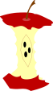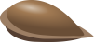 |  |  |  | It is a pip.
 |  |  |  | The pip is in the tin.
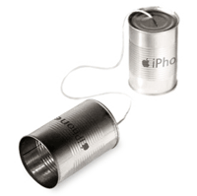 |  |  |  | The tin tips.
 |  |  |  | Tip the pip in the tin.
Pat |  | sit |  |  | sits |  |  | dog |  | by
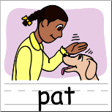 |  |  |  | Pat the dog.
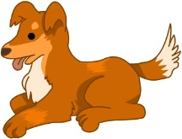 |  |  |  | Pat is a dog.
 |  |  |  | Sit, Pat.
 |  |  |  | Pat sits.
 |  |  |  | Pat sits by the tin.

